# **Dhaka Division Go Back**

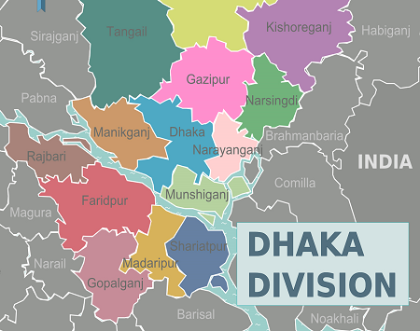**Dhaka Division** is an [administrative division](https://en.wikipedia.org/wiki/Divisions_of_Bangladesh) within [Bangladesh](https://en.wikipedia.org/wiki/Bangladesh).[[1]](https://en.wikipedia.org/wiki/Dhaka_Division#cite_note-Banglapedia-1) The capital and largest city is [Dhaka](https://en.wikipedia.org/wiki/Dhaka). The division covers an area of 20,593.74 square kilometers, and has a population of 36,054,418 at the 2011 Census.

Dhaka Division is bounded by [Mymensingh Division](https://en.wikipedia.org/wiki/Mymensingh_Division" \o "Mymensingh Division) to the north, [Barisal Division](https://en.wikipedia.org/wiki/Barisal_Division) to the south, [Chittagong Division](https://en.wikipedia.org/wiki/Chittagong_Division) on the south-east, [Sylhet Division](https://en.wikipedia.org/wiki/Sylhet_Division" \o "Sylhet Division) to the east, [Rangpur Division](https://en.wikipedia.org/wiki/Rangpur_Division" \o "Rangpur Division) to the north-west, and [Rajshahi](https://en.wikipedia.org/wiki/Rajshahi_Division" \o "Rajshahi Division) and [Khulna Divisions](https://en.wikipedia.org/wiki/Khulna_Division) to the west. Dhaka Division, formerly **Dacca Division** of [East Pakistan](https://en.wikipedia.org/wiki/East_Pakistan) province, consists of two [city corporations](https://en.wikipedia.org/wiki/City_corporation), 13 districts, 93 upazilas and 1,239 union parishads.